TC-VER-003
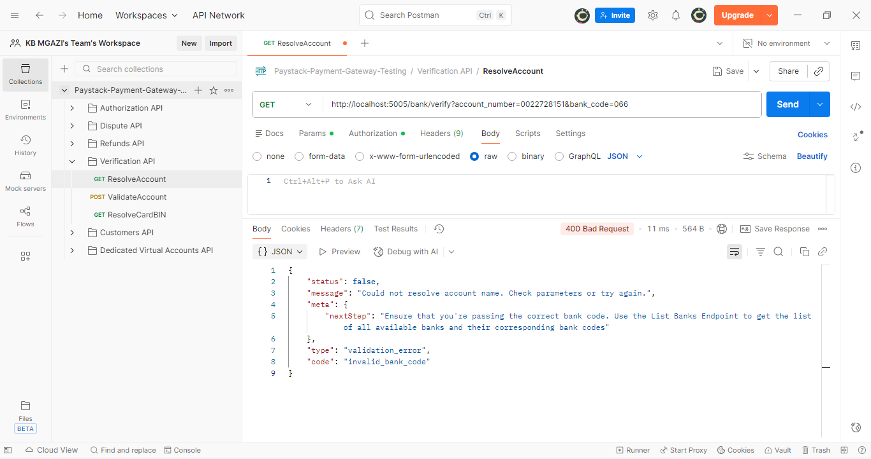
Response:
{
"status": false,
"message": "Could not resolve account name. Check parameters or try again.",
"meta": {
"nextStep": "Ensure that you're passing the correct bank code. Use the List Banks Endpoint to get the list of all available banks and their corresponding bank codes"
},
"type": "validation_error",
"code": "invalid_bank_code"
}

